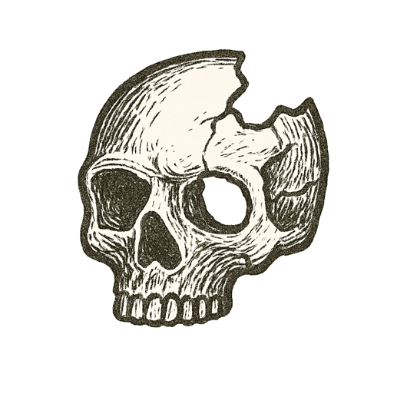

Rain streaked across the windshield, wipers beating in slow, hypnotic arcs. The baby’s cry rose from the back seat, thin and piercing.
A hand fumbled for the bottle on the passenger seat. Eyes darted to the rearview mirror, searching for comfort.
Tires hummed under wet asphalt. A red light glowed ahead, blurred by tears or rain or both.
Five seconds passed.
A horn blared. Brakes screamed. Metal crumpled into night.

A mind, perfect in intent, stilled by a moment’s drift.

